**Assumptions of Linear Regression:**

Linear regression makes several key assumptions about the relationship between the independent variable(s) (features) and the dependent variable (target). These assumptions are essential for the model to be reliable and the results to be interpreted correctly. Here are the main assumptions of linear regression:

1. **Linearity between independent and dependant Feature.**
2. **No Multicollinearity between independent Feature**
3. **Normally distribution of Errors**
4. **Homoscedasticity (Constant Variance) of residuals**
5. **No Autocorrelation of Residuals of residuals**

**1.Linearity between independent and dependant Feature**:

The relationship between the independent variables and the dependent variable is assumed to be linear. This means that changes in the dependent variable are proportional to changes in the independent variables, according to a straight line.

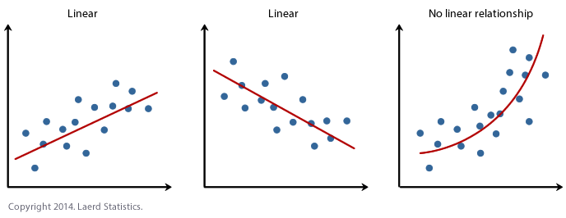

**2. No Multicollinearity between independent Feature:**

There should be no exact linear relationship between the independent variables (multicollinearity). High correlation among independent variables can lead to instability in the estimation of the coefficients.

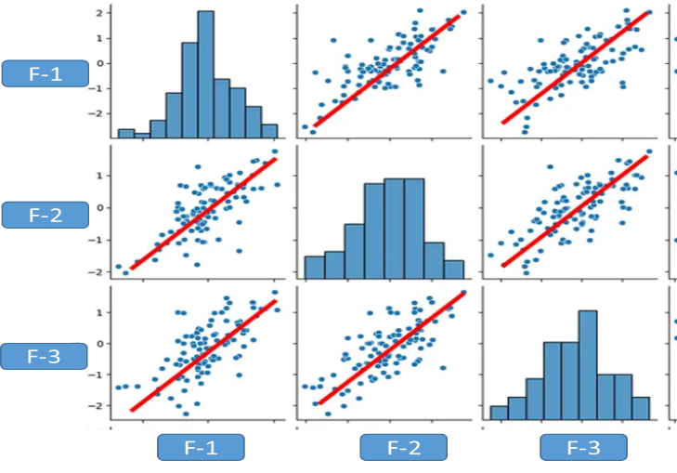

**3. Normally distribution of Errors:**

when we plot the error the plot should be normally distributed.

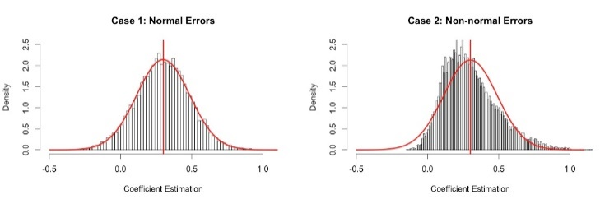

4. **Homoscedasticity (Constant Variance) of residuals(Error):**

The spread of the residuals should be consistent as you move along the range of predicted values.

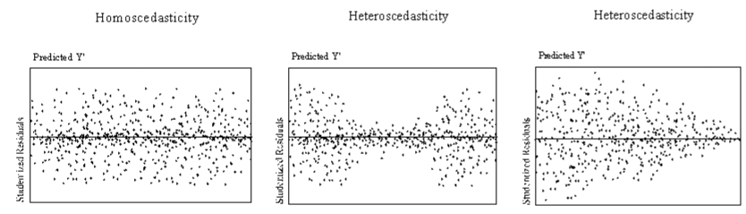

**5. No Autocorrelation of Residuals Error:**

The residuals should not be correlated with each other. Autocorrelation occurs when the residuals from a time series regression are correlated with each other at different lags.

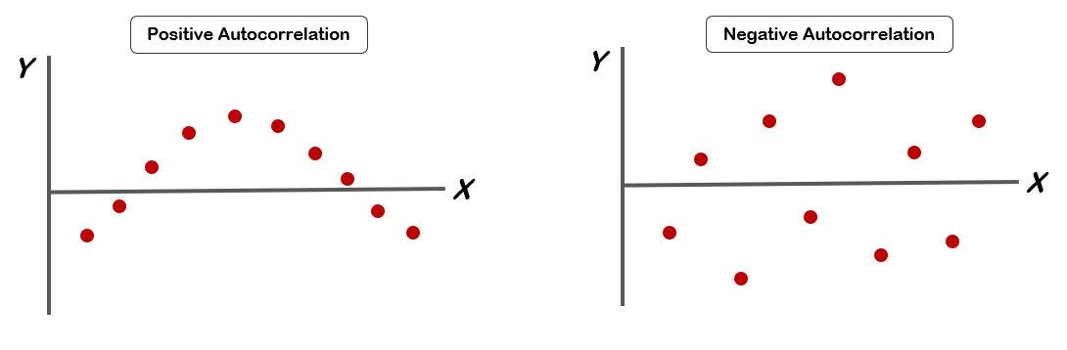

These assumptions are crucial for interpreting the results of a linear regression model correctly and for ensuring the reliability of the conclusions drawn from the analysis. Violations of these assumptions can lead to biased estimates, incorrect inferences, and unreliable predictions. Therefore, it's essential to assess these assumptions when applying linear regression in practice.